Mohammad Widyarta

Universitas Indonesia

**ATAP**

ATAP was a discussion group formed in Holland by a number of Indonesian architecture, interior design, and fine arts students in the mid-1950s. It was not intended as a very serious group, although its members discussed issues such as housing in Indonesia. Nevertheless, members of the group would shape the development of modernist architecture in Indonesia.

These students initially studied in the Netherlands. Those who studied architecture studied at the Technische Hogeschool in Delft (now University of Technology, Delft). However, as relationship between Indonesia and the Netherlands deteriorated due to a dispute between the two countries over West Papua in 1958, these students moved to other European countries.

Some architecture students, such as Han Awal, Mustafa Pamoentjak, SUJUDI WIRJOATMODJO, Liem Bianpoen, and Suwondo B. Sutedjo moved to West Germany. Han Awal, Pamoentjak, and Sujudi enrolled at the Technische Universität, Berlin, while the two others enrolled in the Technische Universität, Hannover.

These architecture students were exposed to modernist architectural ideas. Sutedjo in particular admired the works and ideas of MIES VAN DER ROHE, which is evident in a work by the former, the Institute of Agriculture’s Computer Centre, Bogor (1971). The students’ visit to Scandinavia also exposed them to modern Scandinavian architecture. They later brought these modernist ideas to Indonesia when they went back home within the period of 1960-1962.

Back in Indonesia, ATAP members practised and taught, mostly at the Institut Teknologi, Bandung and Universitas Indonesia (as in 2012, Han Awal still practices and teaches at Universitas Indonesia, while Liem Bianpoen teaches at Universitas Pelita Harapan).

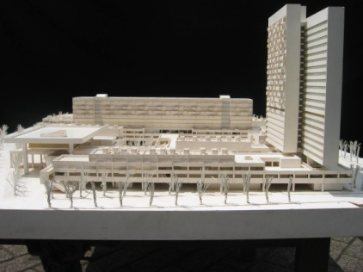

A model of Kota Inti, Jakarta. The scheme, commissioned by a developer, was designed by Han Awal in 1963. This work was almost built. However, the developer failed to reach an agreement with the land owners (Photograph courtesy of Han Awal & Partners).

**List of Works**

1963 Kota Inti, Jakarta (Han Awal).

1971 Institute of Agriculture’s Computer Centre, Bogor (Suwondo B. Sutedjo).

1975 Indonesian Embassy, Kuala Lumpur (Sujudi).

1975 Pertamina Hospital, Cilacap (Suwondo B. Sutedjo).

c. 1969. Kristoforus Church, Jakarta (Liem Bianpoen).

**References and Further Reading**

Herlambang, S. (2012) “ATAP, Delft: 1953 – 1957, Kisah-kisah Kecil tentang Kelompok Diskusi, Perjalanan Arsitektur dan Persemaian Arsitek Modern Indonesia,” in *Tegang Bentang: Seratus Tahun Perspektif Arsitektural di Indonesia*, Jakarta: Gramedia & Pusat Dokumentasi Arsitektur Indonesia.

Personal Interviews with Han Awal, Liem Bianpoen, and Suwondo B. Sutedjo in Jakarta, 2006 - 2007.